Josue Ballona

1. List all lines that have bash or bush, regardless of case.

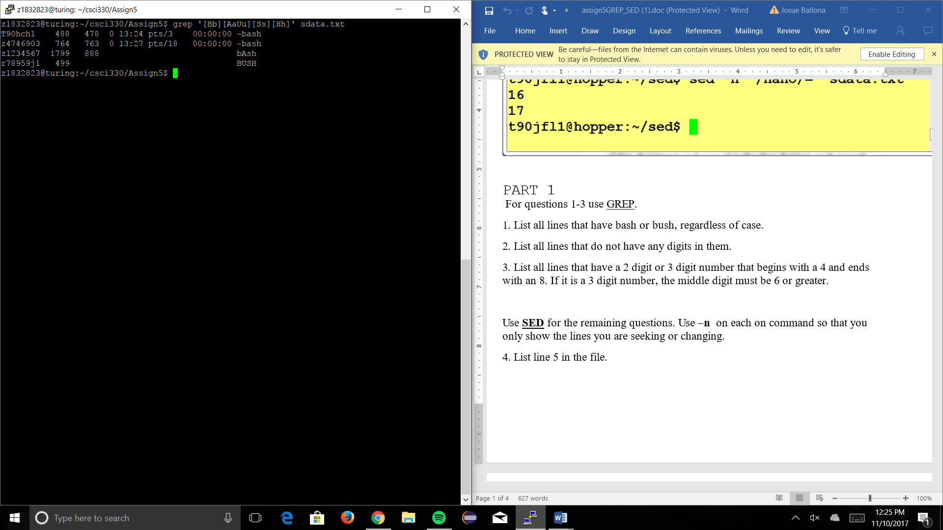

1. List all lines that do not have any digits in them.

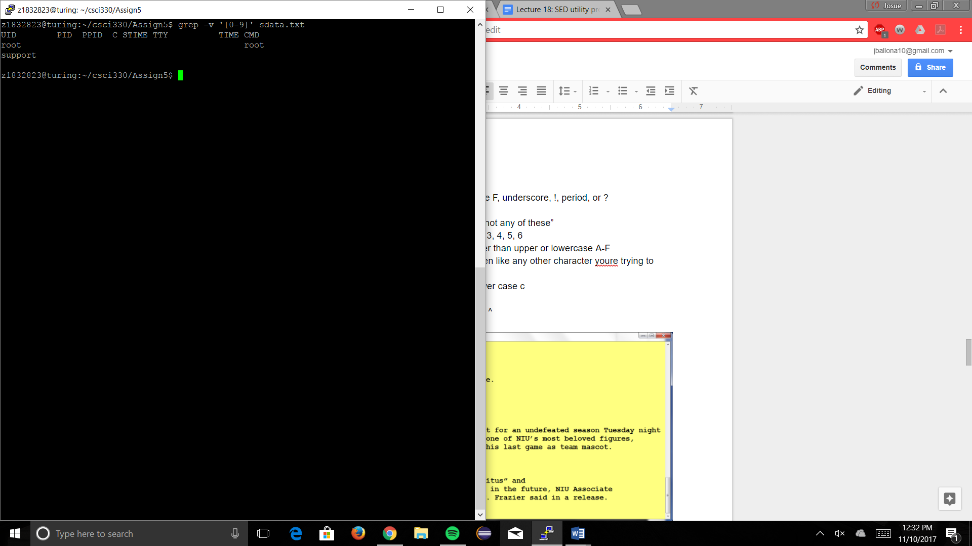

1. List all lines that have a 2 digit or 3 digit number that begins with a 4 and ends with an 8. If it is a 3 digit number, the middle digit must be 6 or greater.

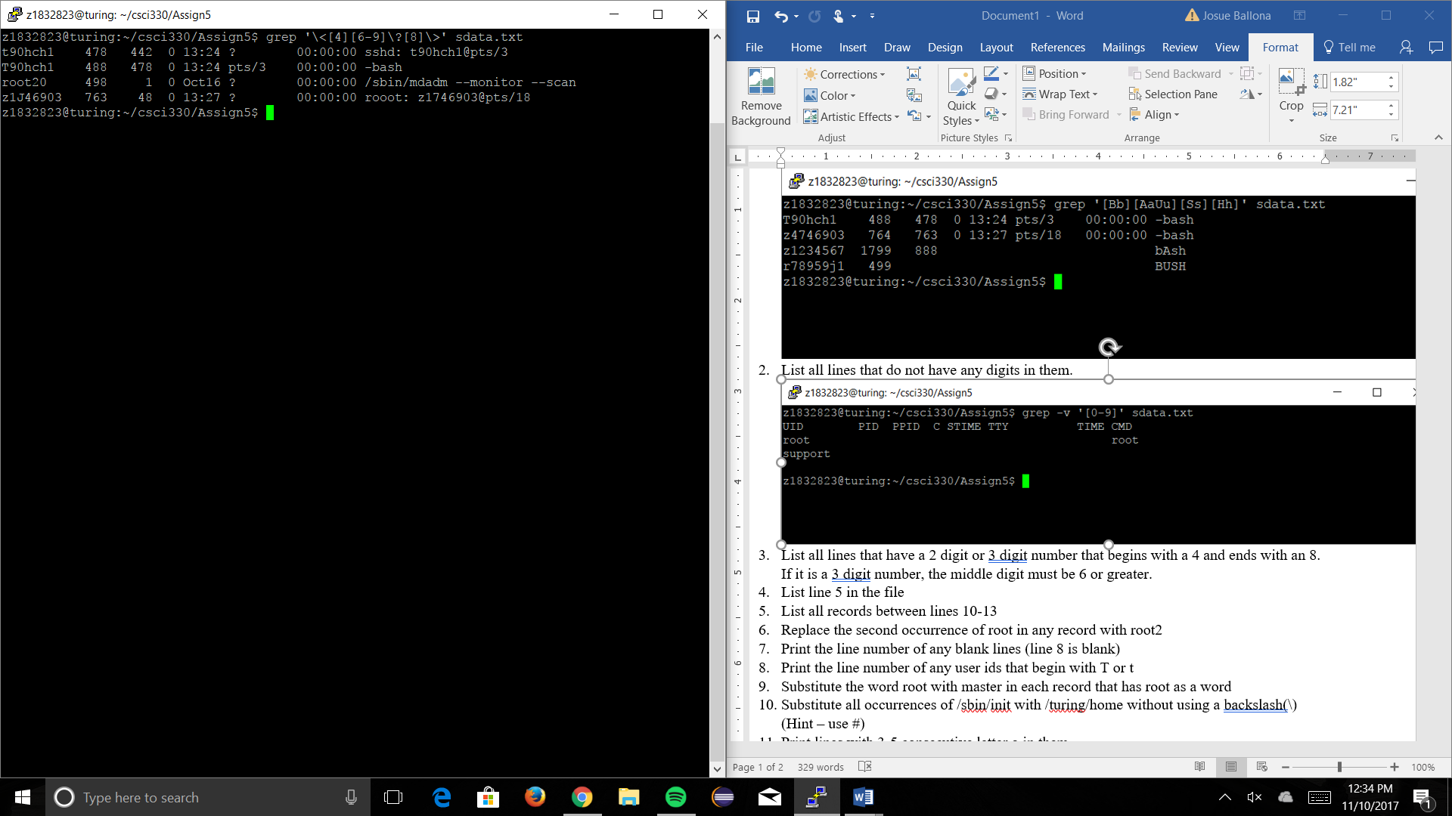

1. List line 5 in the file

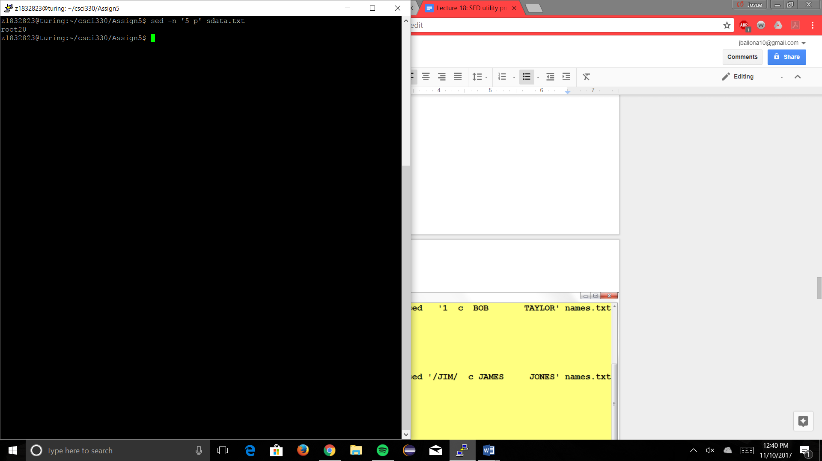

1. List all records between lines 10-13

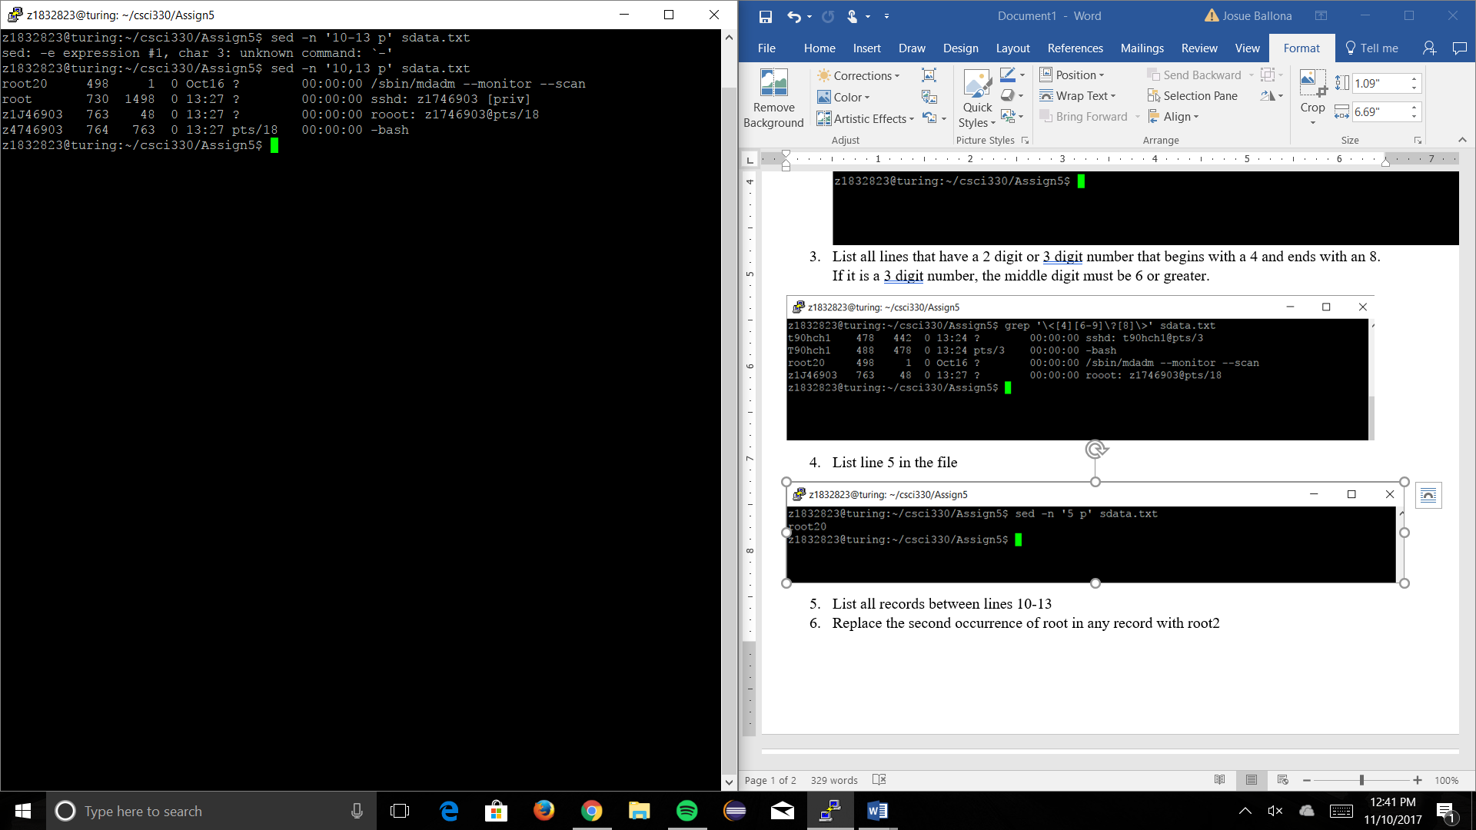

1. Replace the second occurrence of root in any record with root2

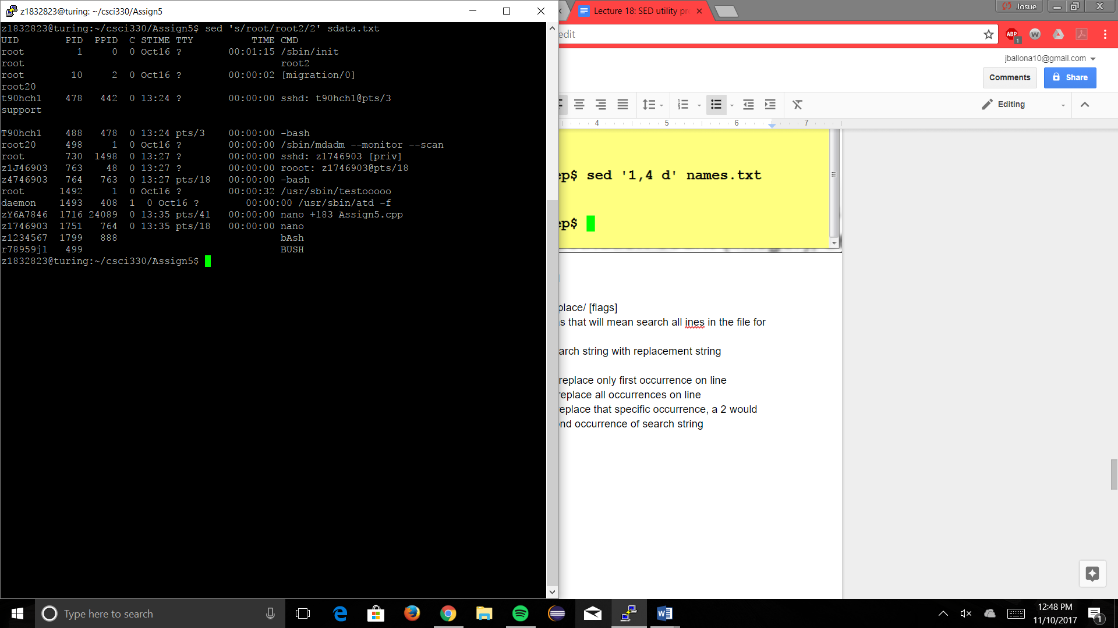

1. Print the line number of any blank lines (line 8 is blank)

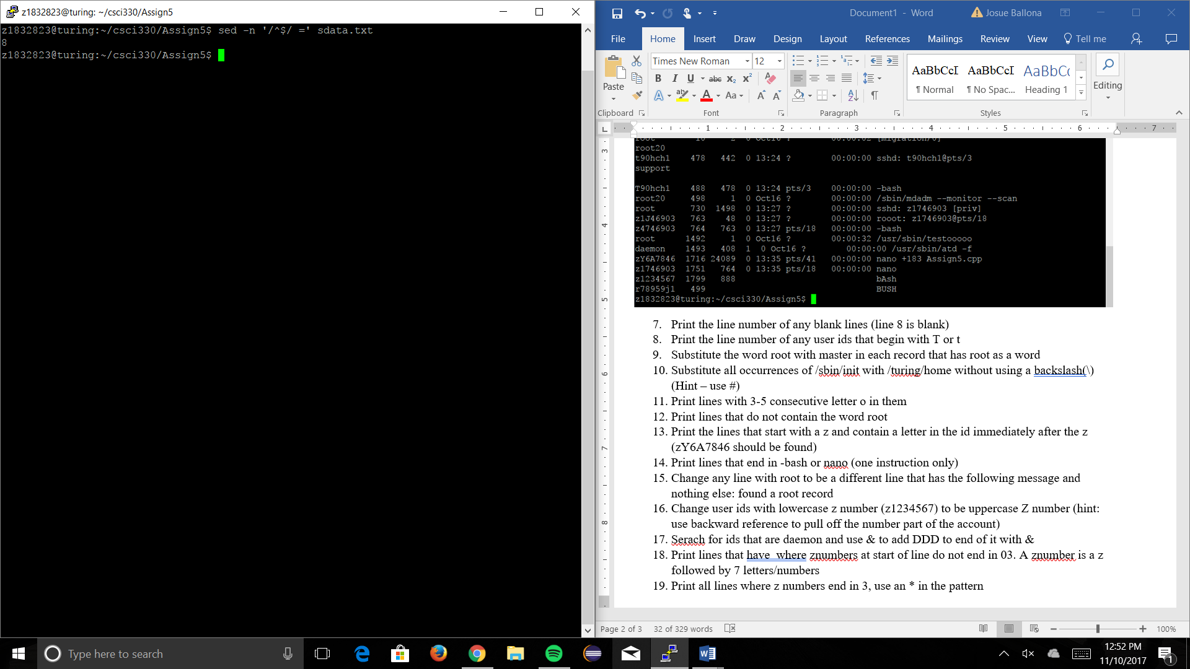

1. Print the line number of any user ids that begin with T or t

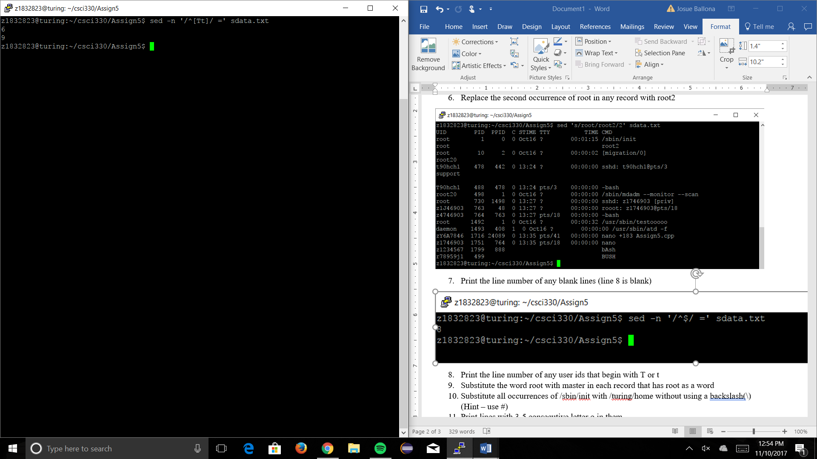

1. Substitute the word root with master in each record that has root as a word

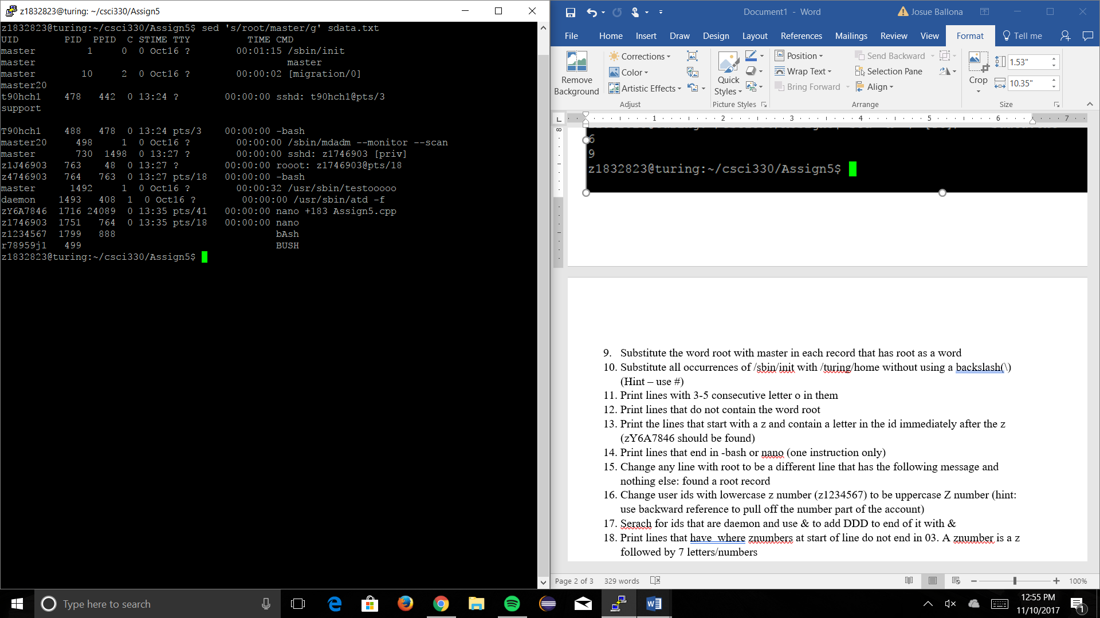

1. Substitute all occurrences of /sbin/init with /turing/home without using a backslash(\) (Hint – use #)

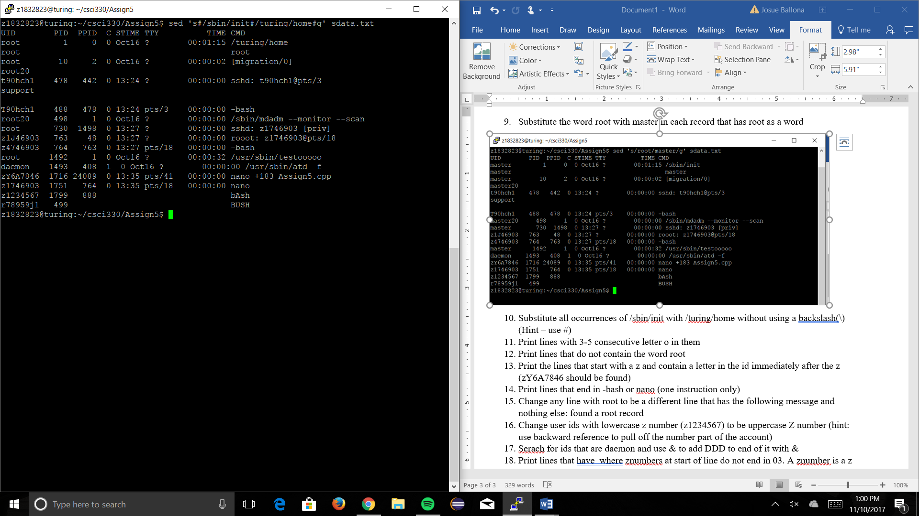

1. Print lines with 3-5 consecutive letter o in them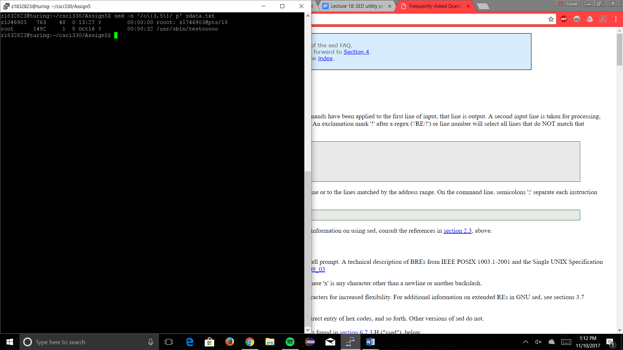
2. Print lines that do not contain the word root

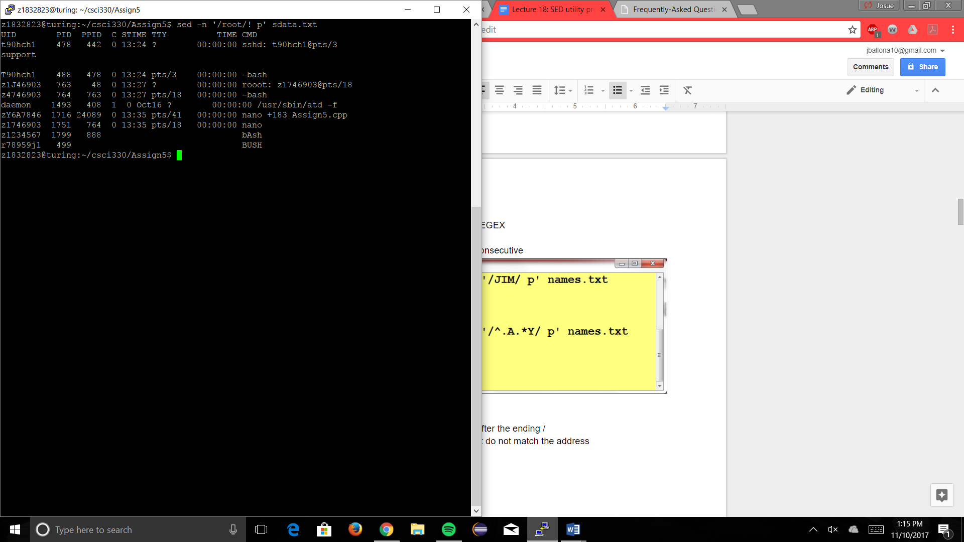

1. Print the lines that start with a z and contain a letter in the id immediately after the z (zY6A7846 should be found)

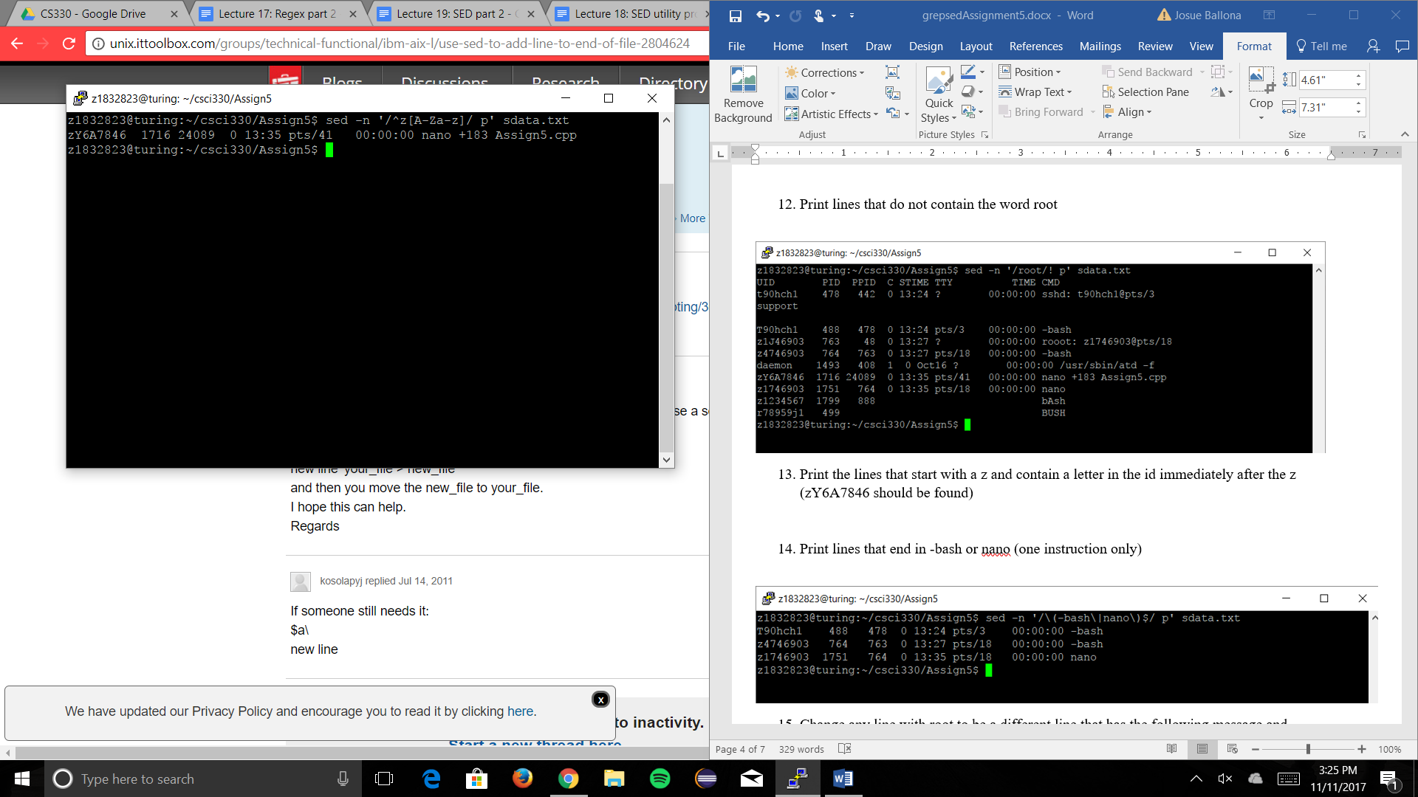

1. Print lines that end in -bash or nano (one instruction only)

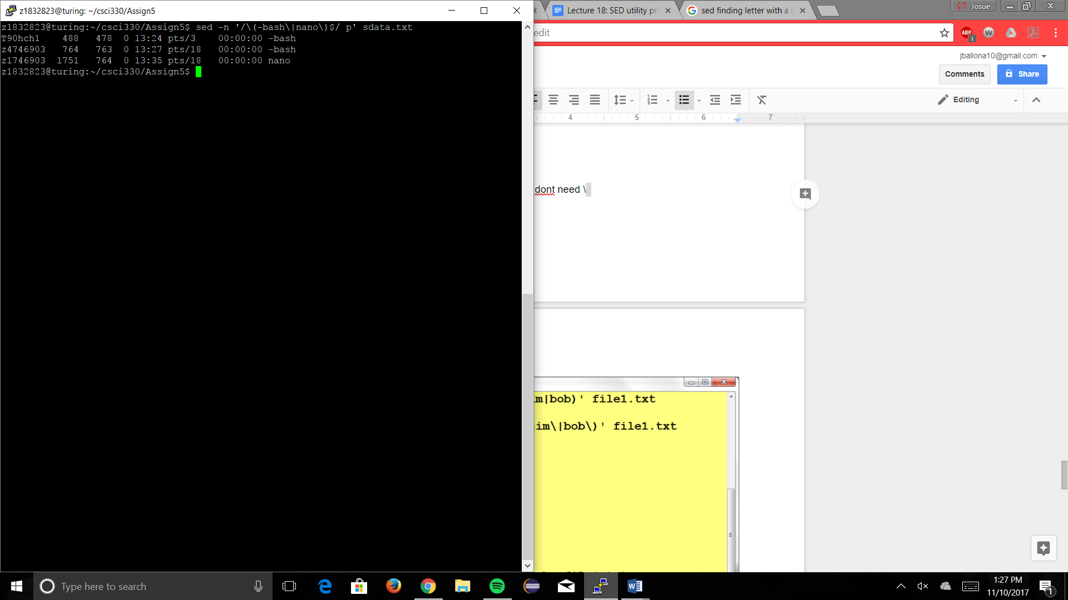

1. Change any line with root to be a different line that has the following message and nothing else: found a root record

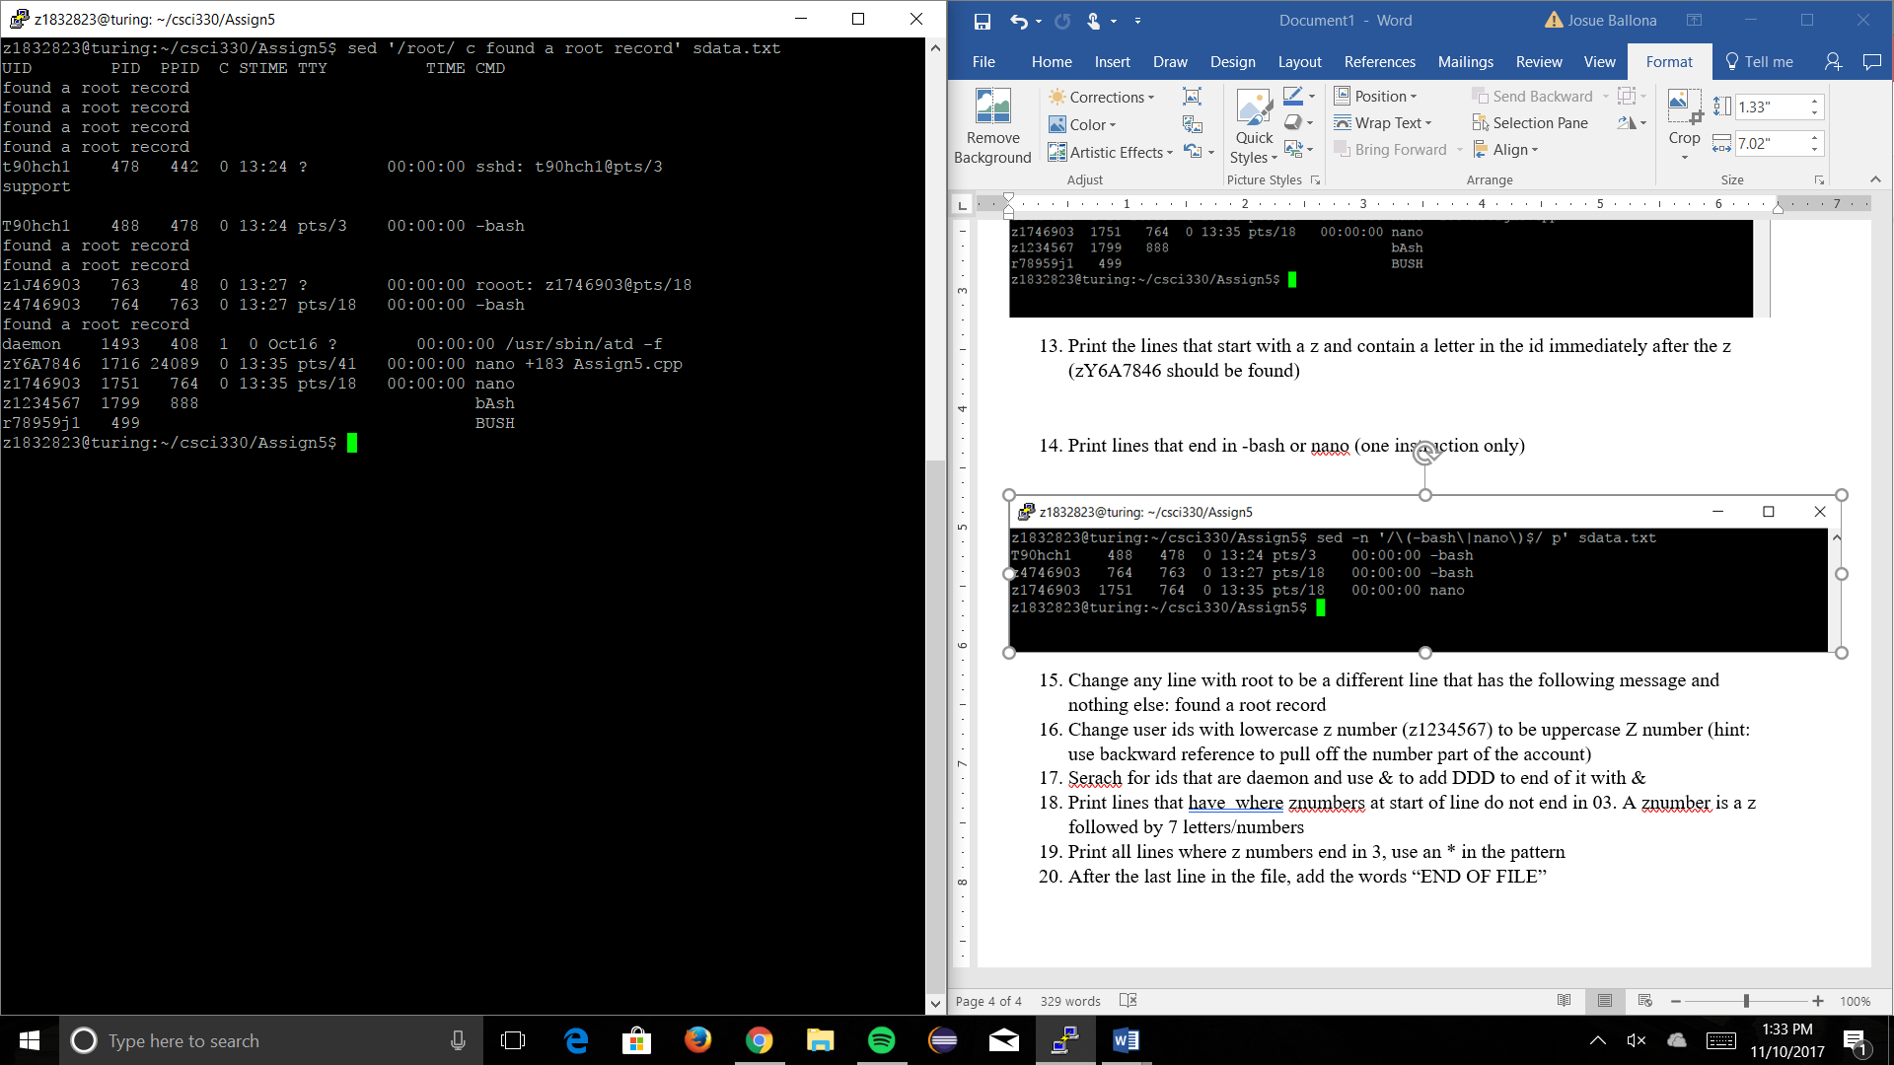

1. Change user ids with lowercase z number (z1234567) to be uppercase Z number (hint: use backward reference to pull off the number part of the account)

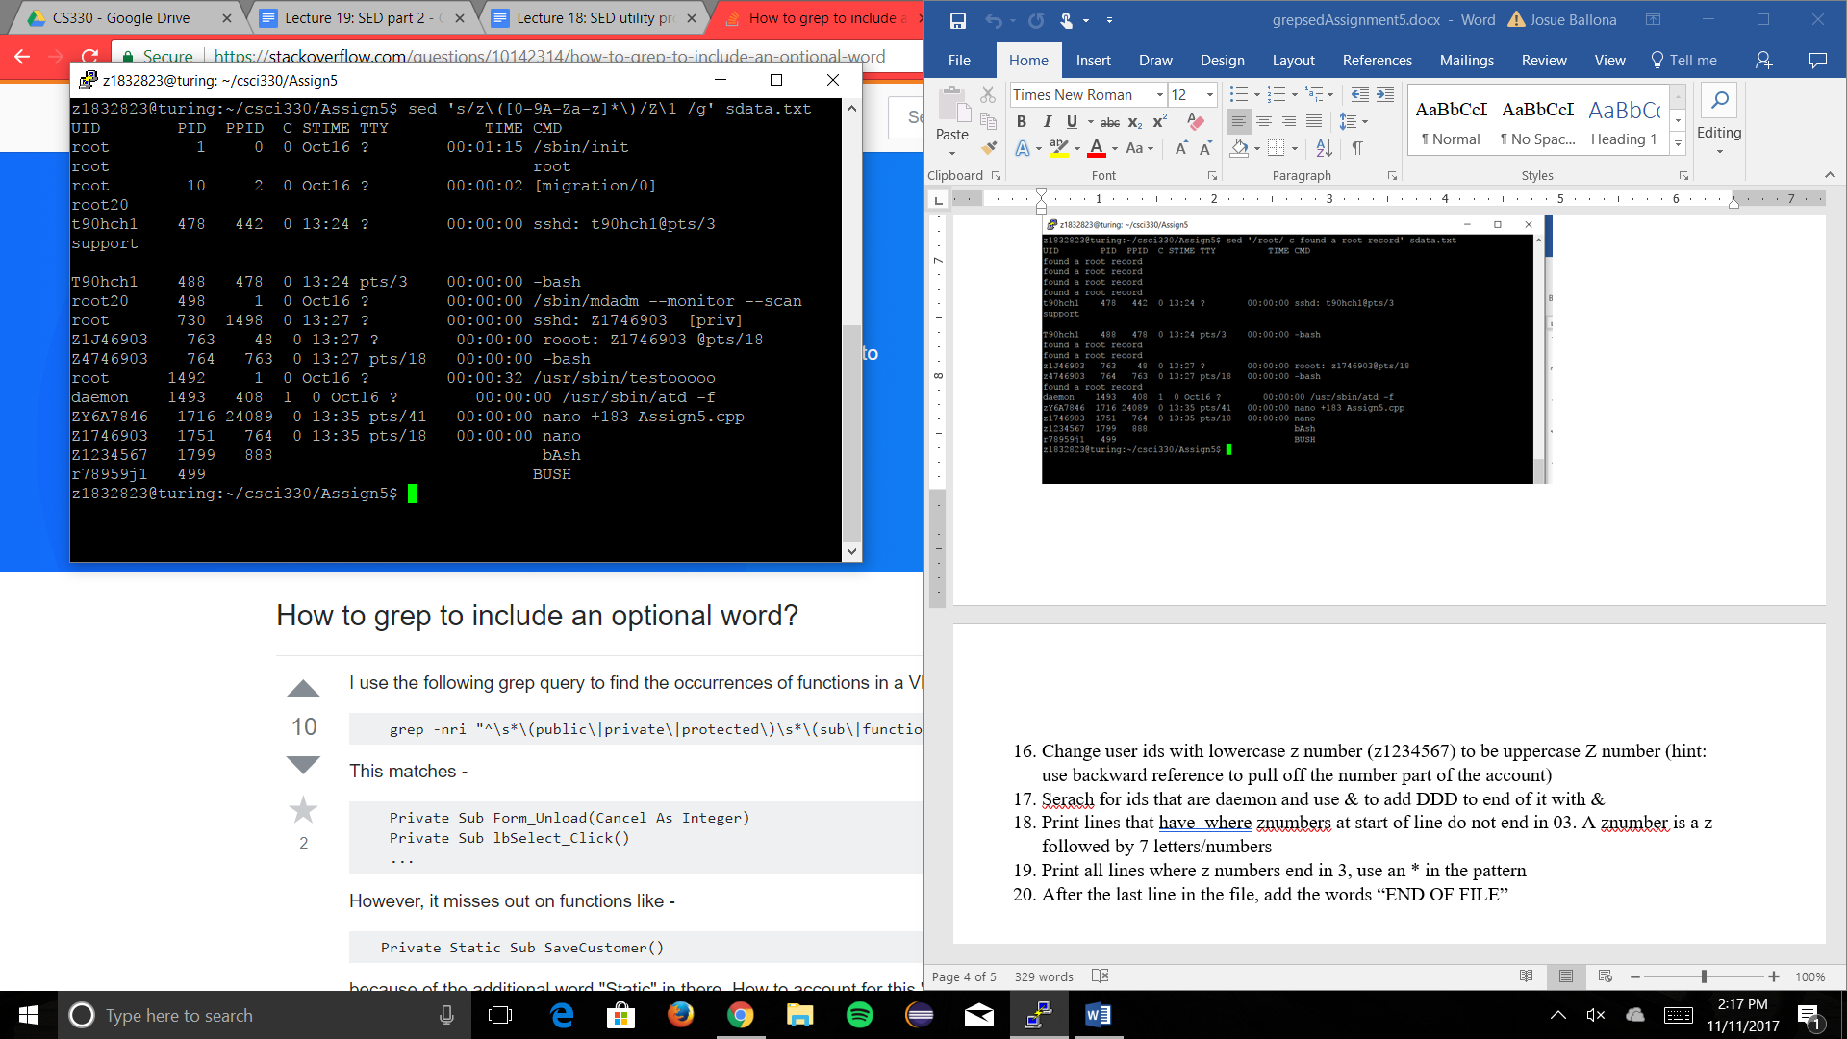

1. Serach for ids that are daemon and use & to add DDD to end of it with &

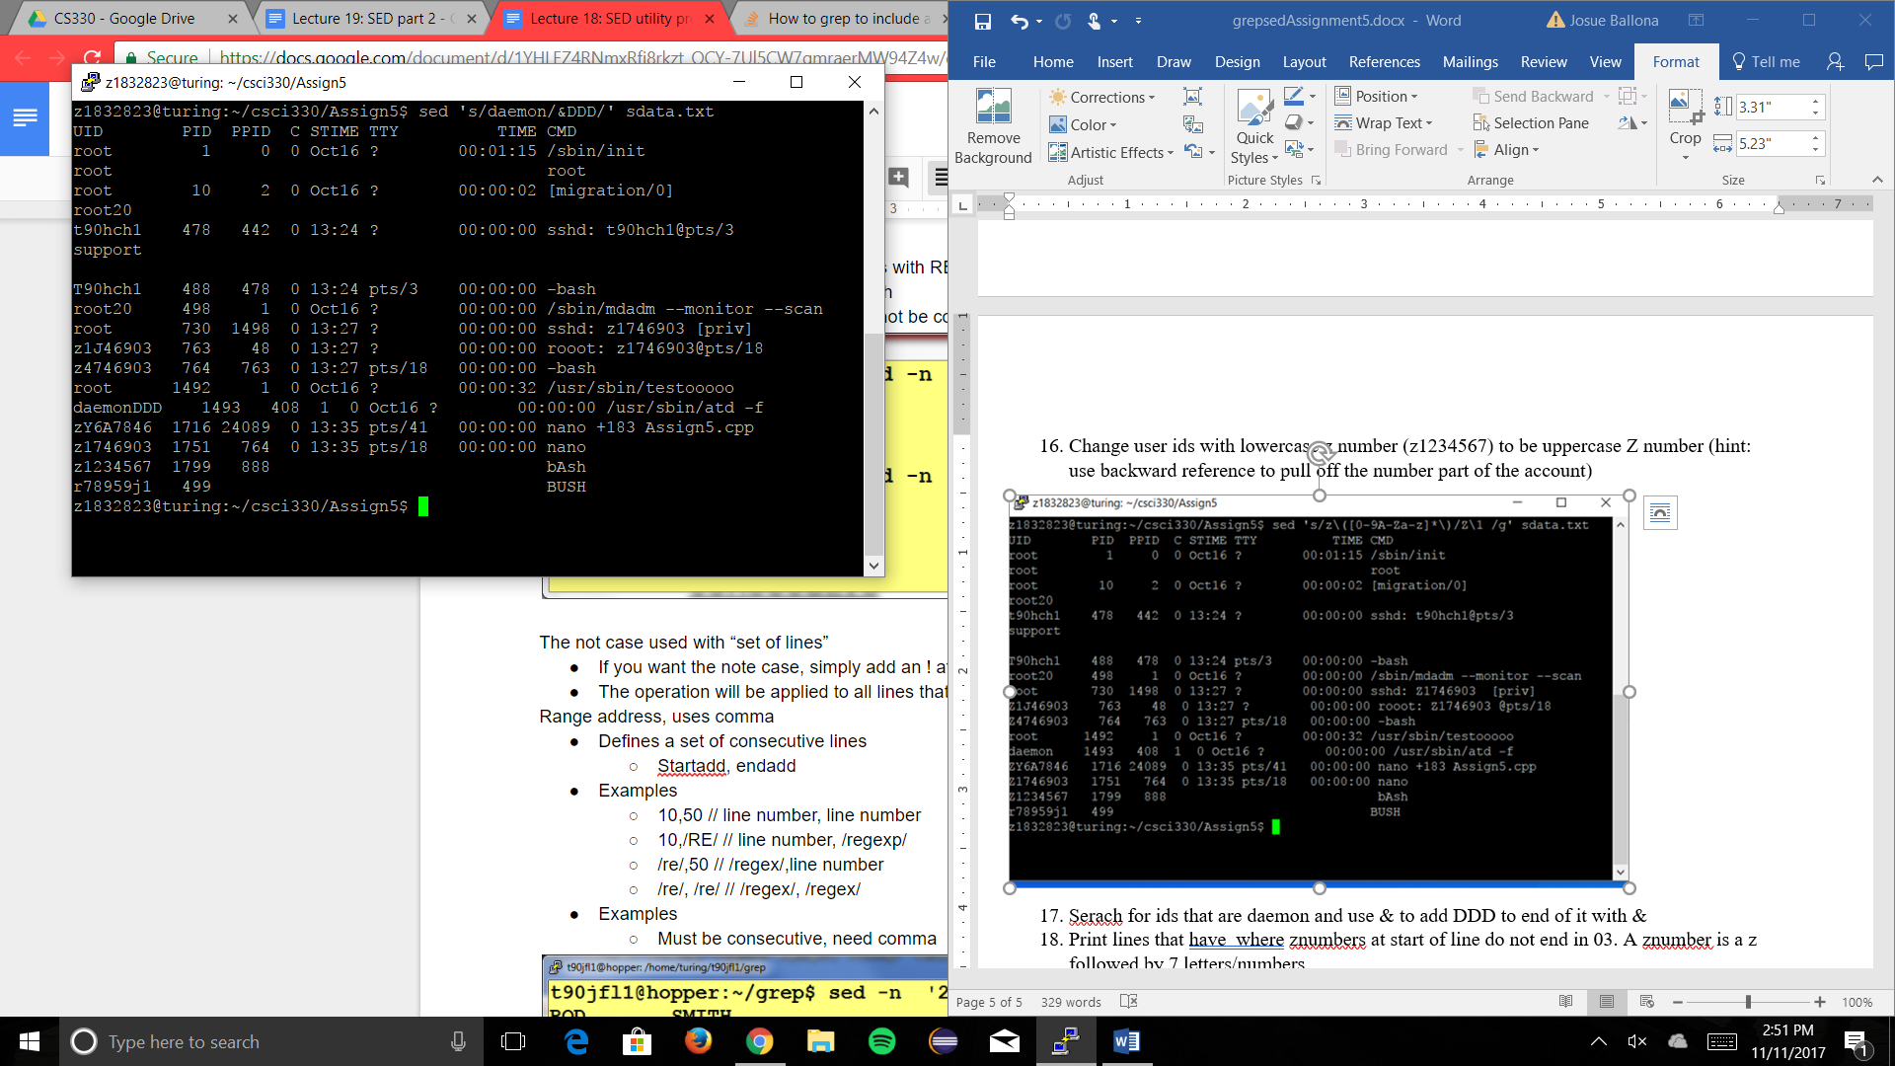

1. Print lines that have where znumbers at start of line do not end in 03. A znumber is a z followed by 7 letters/numbers

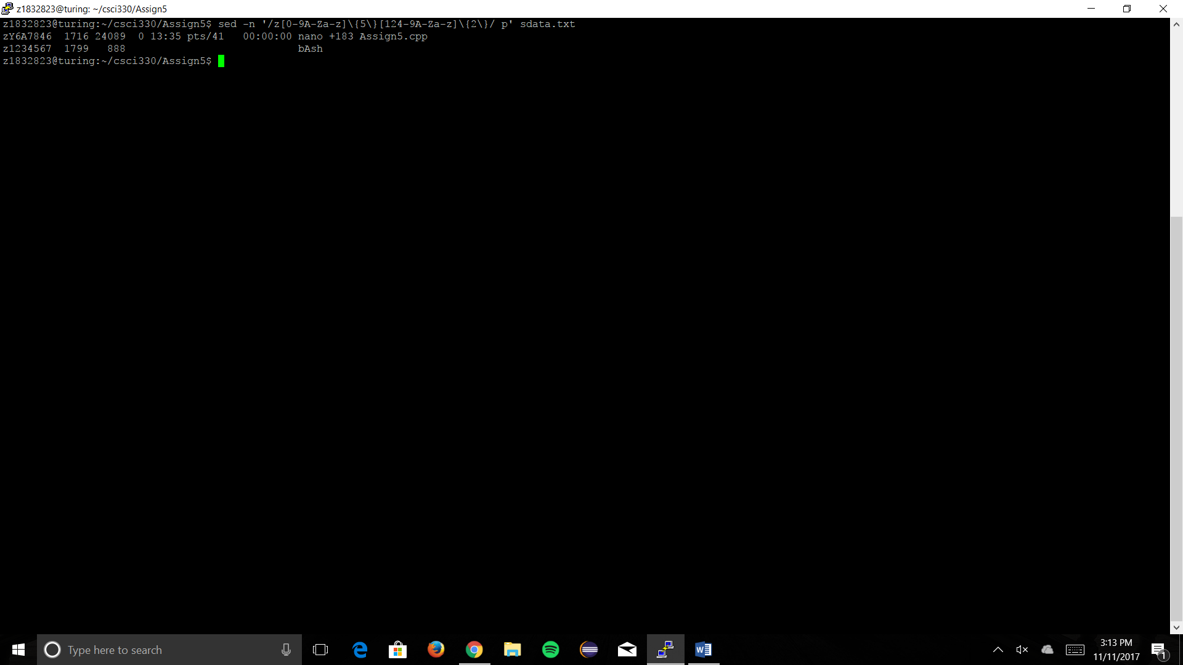

1. Print all lines where z numbers end in 3, use an \* in the pattern

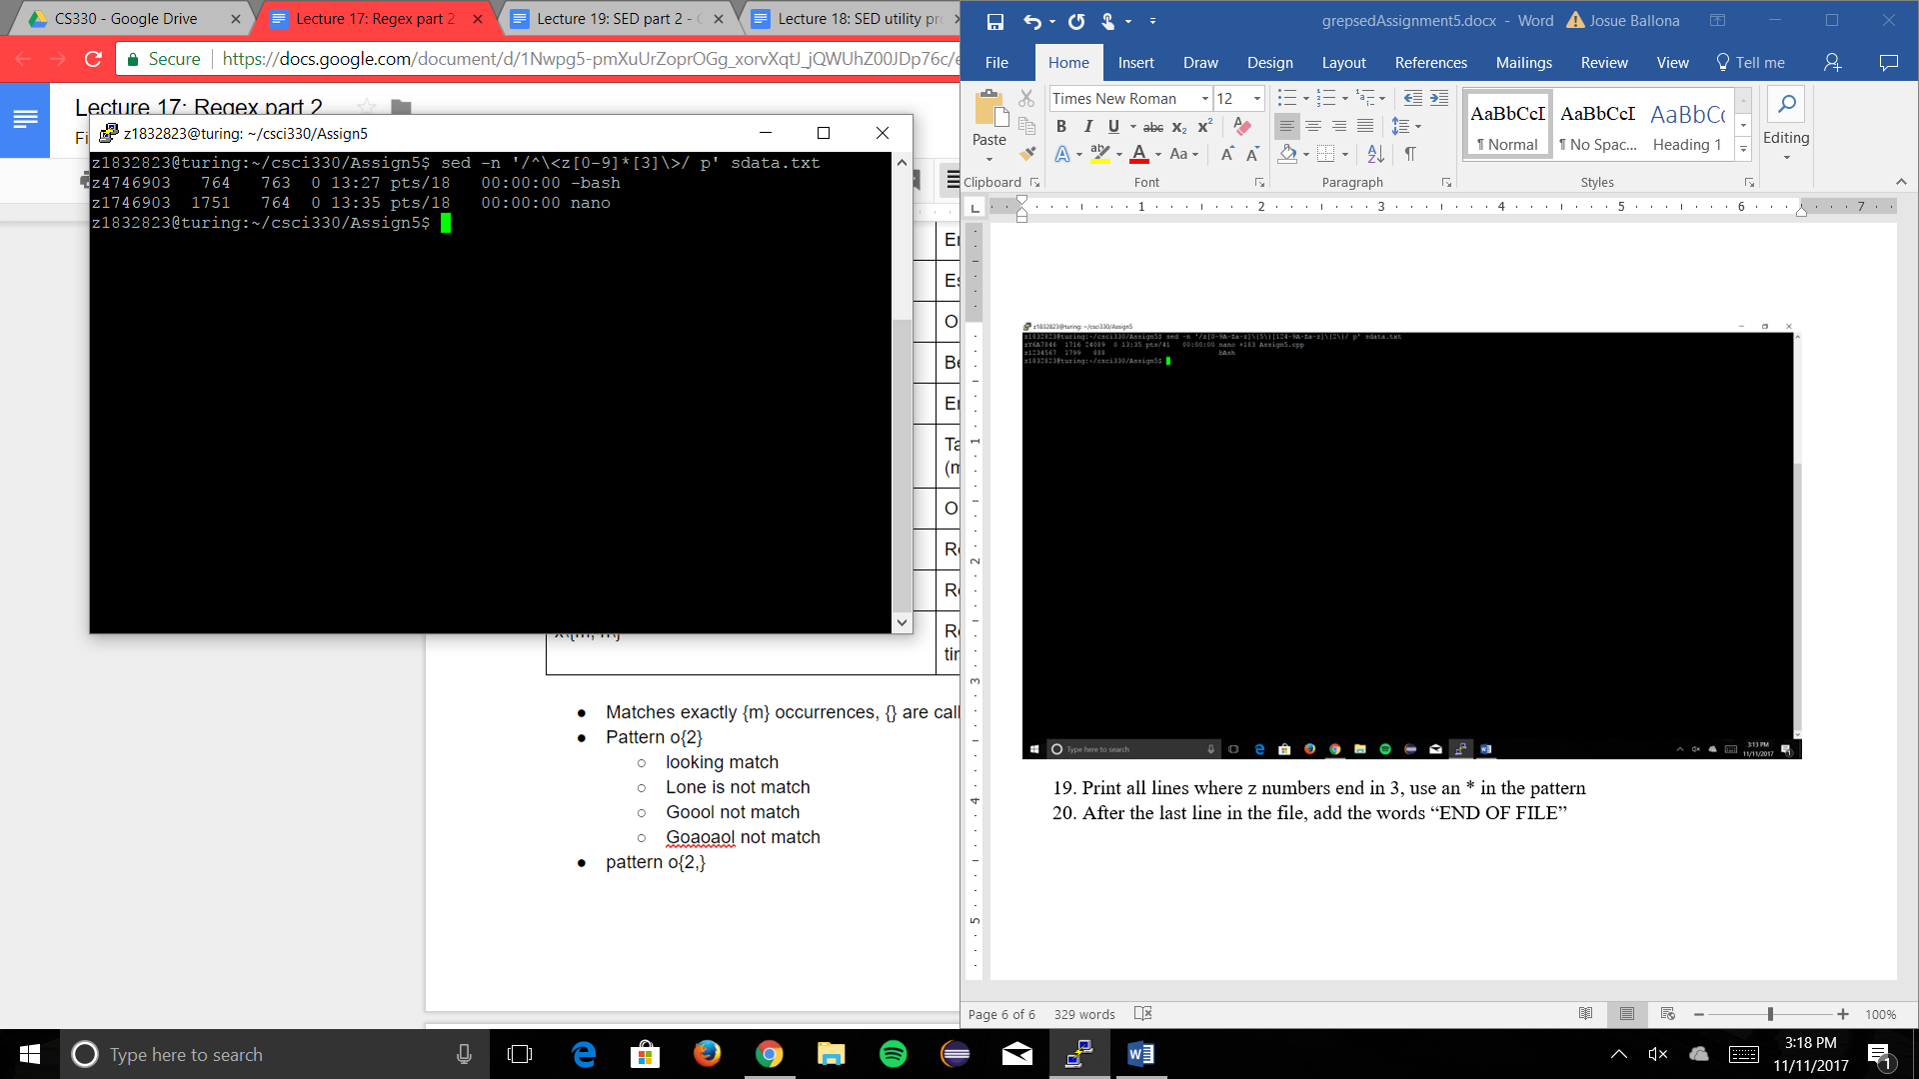

1. After the last line in the file, add the words “END OF FILE”

